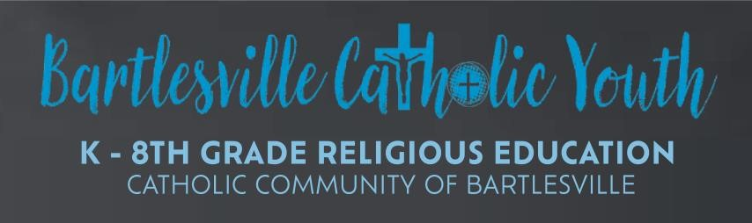 | 2023-2024 Calendar  *dates subject to change as needed*  Kindergarten – 8th Grade  6:00-7:15pm at St. James Church  Classes In English  Contact us: crebartlesville@gmail.com

August | September | October
Registration  (Pick up form in person at each parish or online at St. John parish website) | 6th (cookout)  13th  20th (MS Youth Group)  27th  (First communion parent meeting) | 4th  11th (No Class – Fall Break)  18th (Self Safety& Ask Fr. John night)  25th
November | December | January
1st  8th (Confession Wednesday)  15th (MS Youth group)  22nd (No Class – Thanksgiving Break)  29th | 6th  13th (Ice Skating)  20th (No Class – Christmas Break)  27th (No Class – Christmas Break) | 3rd  10th  17th (reconciliation wkshp)  24th (1st Reconciliation)  31st
February | March | April/May
7th  14th (Ash Wednesday- still have class)  21st  28th | 6th (Confession Wednesday)  13th  20th (No Class – Spring Break)  27th (Live Stations) | 3rd ⁽MS Youth Group)  10th  17th  24th  May 1st (last CRE)
CRE Cookout  September 6  First Communion Parent  Meeting  September 27th  Self-Safety Class  October 18th  Easter  March 31st | *First Reconciliation  Wednesday, January 24th 7:00-  8:30pm@ St. James  *First Communion  Weekend of April 27-28, 2024  Times and exact day TBD  SACRAMENTAL WORKSHOPS  *Reconciliation Workshop  Wednesday, January 17th 6-8pm  *First Communion  Workshop/Rehearsal  Week of April 22nd, 2024, TBD | CRE SUNDAYS  October 8th @ St. John  With Pancake Breakfast and FUN!  February 11th @St. James  with breakfast and FUN!  Middle School Conference  March 9 JCYC

